**ASSIGNMENT-4**

**Q1. Write a program to implement FCFS scheduling algorithms for the following two cases:**

**When Arrival time is same.**

**P# AT BT**

**P1 0 3**

**P2 0 6**

**P3 0 4**

**P4 0 5**

**P5 0 2**

**Implement the FCFS scheduling manually and verify your output.**

#include<stdio.h>

int main(){

int Bt[20],At,Tat[20],Wt[20];

int n,i;

printf("\nEnter the number of processes:");

scanf("%d",&n);

printf("\nSame Arrival time for each Process:");

scanf("%d",&At);

for(i=0;i<n;i++){

printf("\nBurst time of Process[P%d]:",i+1);

scanf("\n%d",&Bt[i]);

}

Wt[0]=0;

for(i=1;i<n;i++){

Wt[i]=Wt[i-1]+Bt[i-1];

Tat[i]=Wt[i]+Bt[i];

}

Tat[0]=Wt[0]+Bt[0];

printf("\n------------------------------------------\n");

printf("P#\t AT\t BT\t WT\t TAT\t\n");

for(i=0;i<n;i++){

printf("P%d\t %d\t %d\t %d\t %d\t\n",i+1,At,Bt[i],Wt[i],Tat[i]);

}

}

**OUTPUT-**

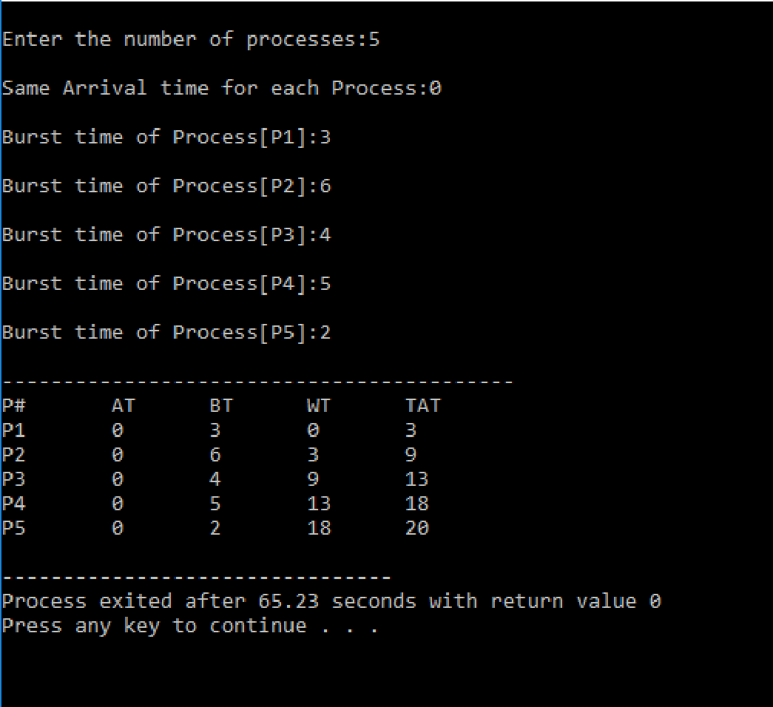

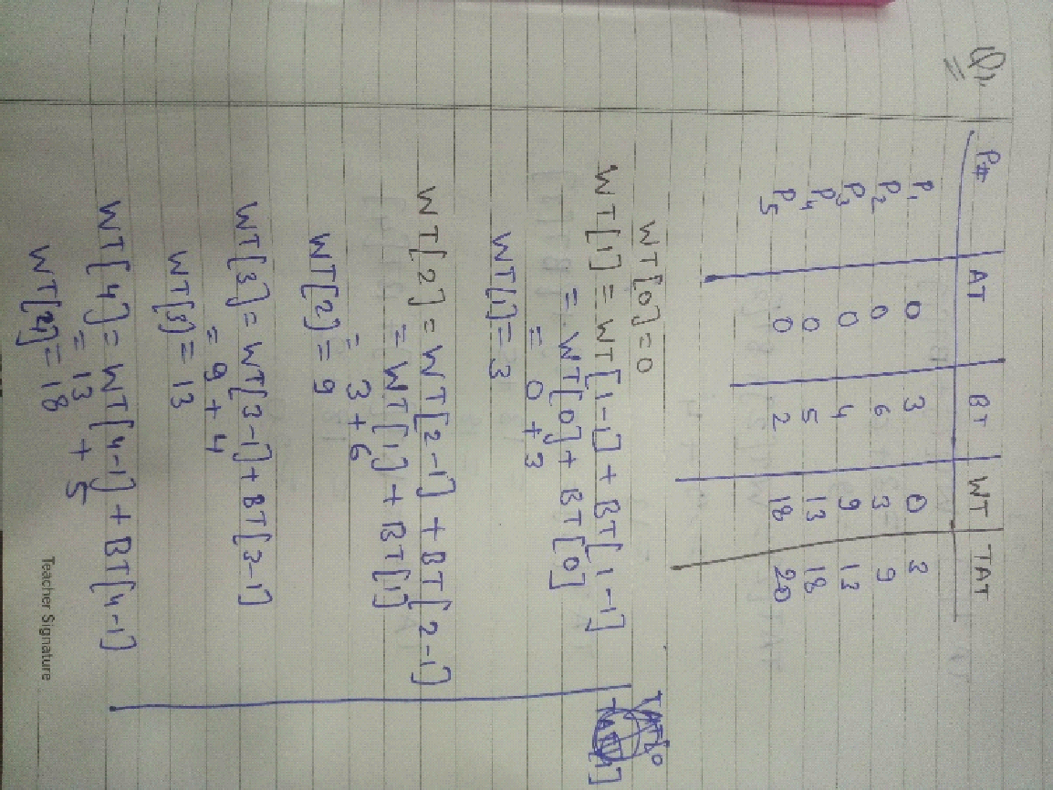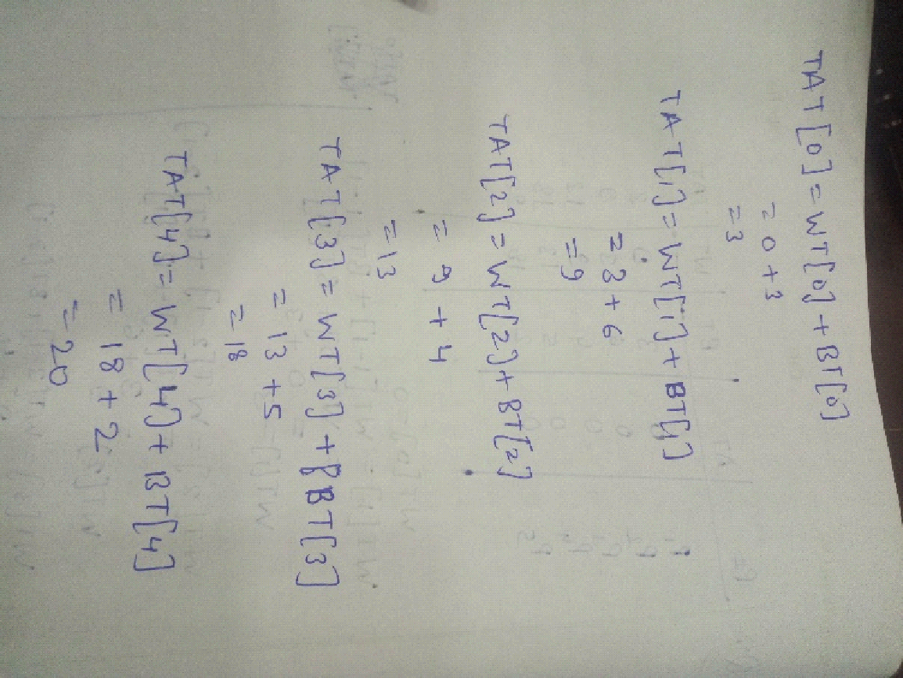

**Q2.When Arrival time is different.**

**P# AT BT**

**P1 0 3**

**P2 2 6**

**P3 4 4**

**P4 6 5**

**P5 8 2**

**Implement the FCFS scheduling manually and verify your output.**

#include<stdio.h>

int main(){

int Bt[20],At[20],Tat[20],Wt[20];

int n,i,j;

printf("\nEnter the number of processes:");

scanf("%d",&n);

printf("\nArrival Time and Burst Time for each process:-\n");

for(i=0;i<n;i++){

printf("\nArrival time of Process[P%d]:",i+1);

scanf("%d",&At[i]);

printf("\nBurst time of Process[P%d]:",i+1);

scanf("%d",&Bt[i]);

}

Wt[0]=0;

for(i=1;i<n;i++){

Wt[i]=0;

for(j=i-1;j>=0;j--){

Wt[i]=Wt[i]+Bt[j];

}

Wt[i]=Wt[i]-At[i];

Tat[i]=Wt[i]+Bt[i];

}

Tat[0]=Wt[0]+Bt[0];

printf("\n------------------------------------------\n");

printf("P#\t AT\t BT\t WT\t TAT\t\n");

for(i=0;i<n;i++){

printf("P%d\t %d\t %d\t %d\t %d\t\n",i+1,At[i],Bt[i],Wt[i],Tat[i]);

} }

**OUTPUT-**



